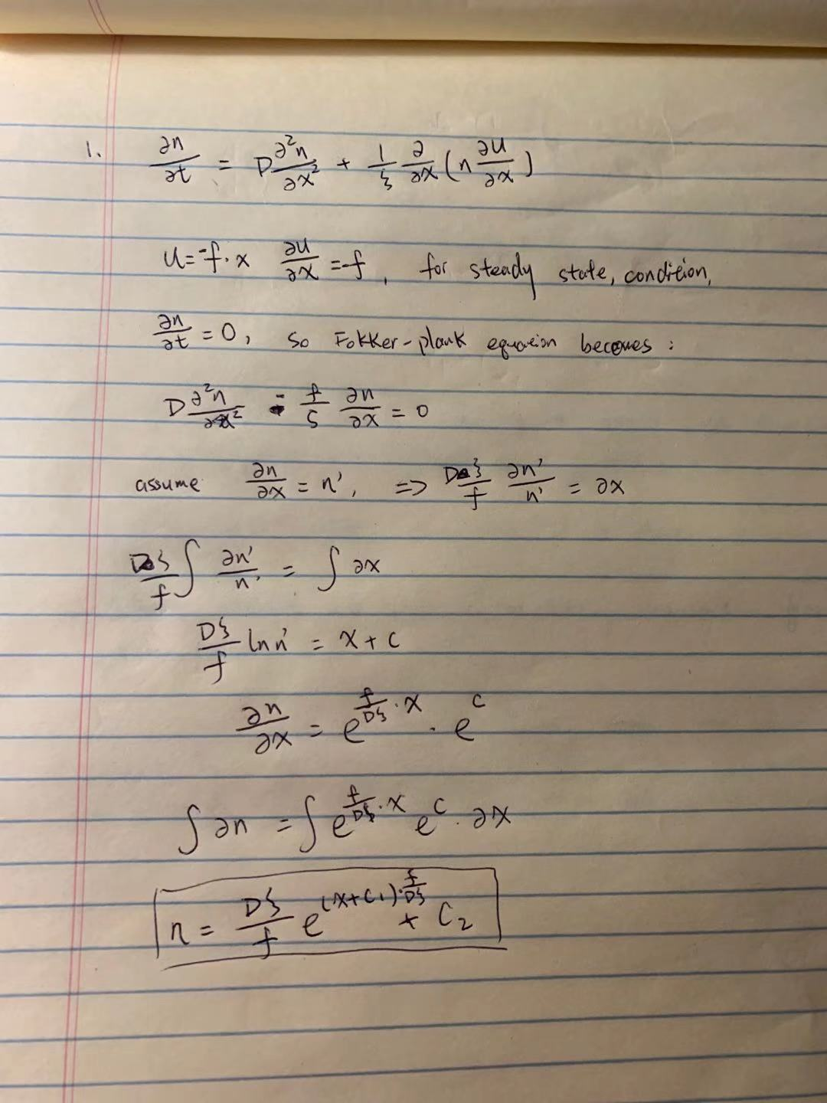

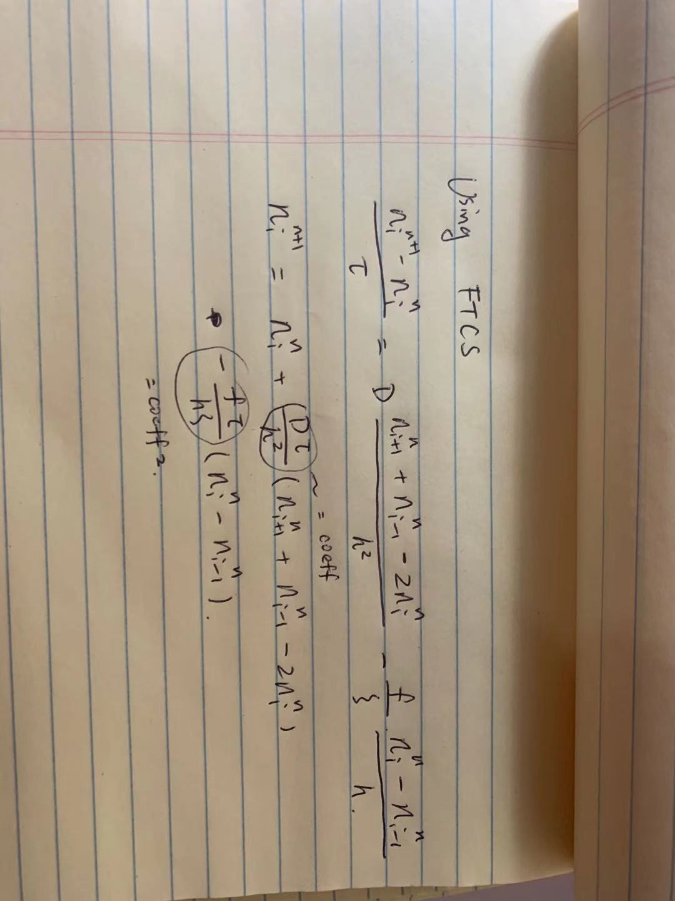

For numerical method, time step is 0.01, number of grid points are 20, total length is 10, number of time step is 10e6.

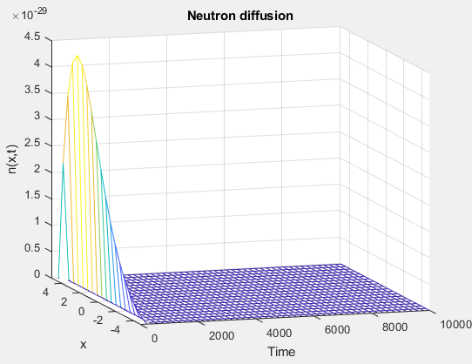

This plot shows the value of n in different x and t, we can find after some time, n will not change with time increasing, which reaches the steady state.